Colors of Spain

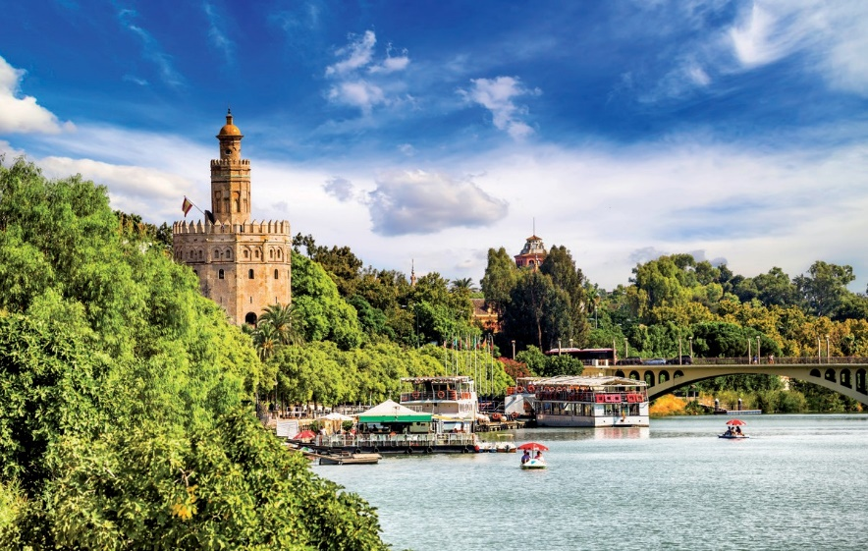

SEVILLE

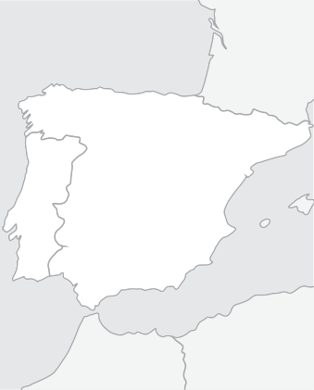

Málaga

Granada

Seville

Córdoba

Mérida

**SPAIN**

Madrid

**Guaranteed Departure Tours**

**Spain & Portugal**

## AVE train from Málaga to Madrid included

From 650 €

9 days

Madrid - Seville - Cordoba - Granada - Costa del Sol

# Departures from Madrid: Sunday

**2019**

|  |  |
| --- | --- |
| March | 31 |
| April | 07, 14, 21, 28 |
| May | 05, 12, 19, 26 |
| June | 02, 09, 16, 23, 30 |
| July | 07, 14, 21, 28 |
| August | 04, 11, 18, 25 |
| September | 01, 08, 15, 22, 29 |
| October | 06, 13, 20, 27 |
| November | 03, 10, 24 |
| December | 08, 22, 29 |
| 2020 |  |
| January | 05, 19 |
| February | 02, 16, 30 |
| March | 08, 15, 22, 29 |
| April | 05, 12, 19, 26 |

the Plaza de España and the Plaza de Oriente. Free time for luncheon on your own. PACKAGE includes a Lunch today. Highly recommended this afternoon, is an op- tional tour to the Imperial former capital city of Toledo, where you will be escorted through its narrow cobblestone streets, soaking up the medieval atmosphere. Touring will include the interior of the magnificent Gothic cathedral

## Day 5, Thursday: SEVILLE - COR- DOBA - GRANADA

Buffet breakfast. Depart to Cordoba. Visit one of the world’s marvels, the former Great Mosque (now a cathedral). Free time for lunch on your own. Continue to Granada, passing thousands of acres of olive groves. PACKAGE includes dinner to- night. This evening, an excellent suggestion

Price per Person in Euros In Double / Twin room

and a visit to St. Tome Church, where El Gre-

would be to visit (optional) the quaint and

## Day 1, Sunday: MADRID

Arrival at Madrid airport. After clearing sim- ple immigration and customs formalities, you will be transferred to your First Class hotel. It is suggested you take advantage of the free

co’s masterpiece painting is displayed. There will also be some time for shopping for the unique typical local artisanry. PACKAGE includes the Tour to Toledo. Re- turn to Madrid for accommodations.

## Day 3, Tuesday: MADRID - ME- RIDA - SEVILLE

Buffet breakfast. Departure through the once-remote region of Extremadura, home to many of the “conquistadors”. Arrival in ancient Merida. Free time for lunch. (Lunch included in PACKAGE.) In the afternoon, visit the impressive Roman am-

typical Albaicin quarter, where Andalusian customs, music and wine join to create an enchanting atmosphere. (PACK- AGE includes this visit).

## Day 6, Friday: GRANADA - COSTA DEL SOL

Buffet breakfast. This morning, enjoy an escorted tour of the magnificent Alhambra and the verdant Gardens of the Generalife. Departure to the world-famous resort area of the Costa del Sol. Accommodations.

## Day 7, Saturday: COSTA DEL SOL

Tour 9 days: Madrid / Madrid

Category Confort Hotels

March 31 / April 14, 2019

April 21 / June 23

June 30 / August 25

September 01 / October 20

October 27 / March 22, 2020

March 29, 2019 / April 26, 2020

Supl. Single Room Apr 1/Oct 31, 2019 + Apr 2020 Supl. Single Room Nov 1, 2019 / Mar 31, 2020

1.035

960

940

960

870

1.020

340

275

time to get to know one of Europe’s most

phitheatre archeological site before contin-

Buffet breakfast. Free day to enjoy this va-

Category Superior Hotels

dynamic capital cities. In the early evening, enjoy an “Illuminated Madrid” drive through the bustling streets of the old city, ending at the historical and impressive Plaza Mayor. This area is home to some of the most typical restaurants and taverns, which serve the deli- cious “tapas”. PACKAGE includes a Tapas Dinner tonight. Return to your hotel at your own convenience. Accommodations.

## Day 2, Monday: MADRID

Buffet breakfast. This morning’s escorted sightseeing tour will allow you to get a glimpse of some of Madrid’s most outstand- ing attractions, like the Puerta del Sol, the magnificent fountains of Neptune and Cibe- les, the stately Alcala Gate, the busy Gran Via,

uing to Seville.Accommodations.



**TOUR FEATURES**

P Transfers airport-hotel-airport

P Accommodations in hotels of Category Confort or Superior

P Bountiful buffet breakfast daily

P Deluxe air-conditioned motorcoach transportation

P Professional tour escort throughout (bilingual English/Spanish)

P Escorted sightseeing tours with bilingual guide in Madrid, Granada, and Seville

P Entrace to Alhambra

P Evening Illuminations tour of Madrid

P Train Tickets Tourist Class Train AVE Malaga/Madrid (Tour 9 days)

P Travel bag

**OPTIONAL PACKAGE INCLUDES**

8 & 9 DAYS: MADRID / MADRID O COSTA DEL SOL: **120 €** · INCLUDES 5 MEALS AND 3 EXTRAS

P “Tapas” dinner in Madrid P Lunch in Madrid or Toledo. P Tour to Toledo

P Lunch in Merida

P Lunch in Seville

P Dinner in Granada

P Tour Show of the Albaicin in Granada

P Flamenco show in Seville

7

## Day 4, Wednesday: SEVILLE

Buffet breakfast. This morning’s marvelous tour will explore this gracious and charming city, Spain’s third largest. See the Tower of Gold, the tranquil and extensive Maria Luisa Park, the quaint Santa Cruz Quarter, and fi- nally the huge cathedral (one of the world’s largest) with its Giralda Tower (a former min- aret). Free time for luncheon on your own. (Lunch Included in PREMIUN PACKAGE) The afternoon is free to continue to explore or shop. This evening an optional Flamenco Show is suggested, with the enjoyment of local wine. PACKAGE include Flamenco Show and drink. Accommodations.

cationer’s paradise. Accommodation.

## Day 8, Sunday: COSTA DEL SOL

- MADRID

Buffet Brealfast. Transfer to the rail station to take the fast train AVE to Madrid in Tourist Class. Arrive in Madrid and transfer to your Hotel for Accomodation.

## Day 9, Monday: MADRID

Buffet Breakfast, Transfer to the airport.

March 31 / April 14, 2019

April 21 / June 23

June 30 / August 25

September 01 / October 20

October 27 / March 22, 2020

March 29, 2019 / April 26, 2020

Supl. Single Room Apr 1/Oct 31, 2019 + Apr 2020 Supl. Single Room Nov 1, 2019 / Mar 31, 2020

1.080

|  |  |
| --- | --- |
| HOTELS USED  or similar | |
| Category Confort Hotels | |
| Madrid  Seville Granada  C. del Sol Madrid | Praga /Holiday Inn Piramides Muralto / Chamartin  M.A. Sevilla Congresos Abades Nevada Palace Hilton Garden Inn  Praga /Holiday Inn Piramides  Muralto / Chamartin |
| Category Superior Hotels | |
| Madrid  Seville Granada  C. del Sol Madrid | Praga /Holiday Inn Piramides Muralto / Chamartin  Melia Lebreros  G.H. Luna / Catalonia Hilton Garden Inn  Praga /Holiday Inn Piramides  Muralto / Chamartin |

1.025

995

1.025

940

1.090

410

345